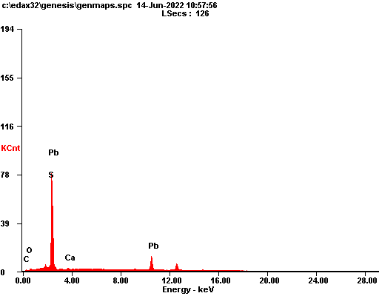

|  |  |  |
| --- | --- | --- |
| ***Element*** | ***Wt%*** | ***At%*** |
| ***CK*** | 04.90 | 32.20 |
| ***OK*** | 01.47 | 07.25 |
| ***SK*** | 11.26 | 27.72 |
| ***CaK*** | 00.91 | 01.79 |
| ***PbL*** | 81.47 | 31.04 |
| ***Matrix*** | Correction | ZAF |

